Checkers Game Manual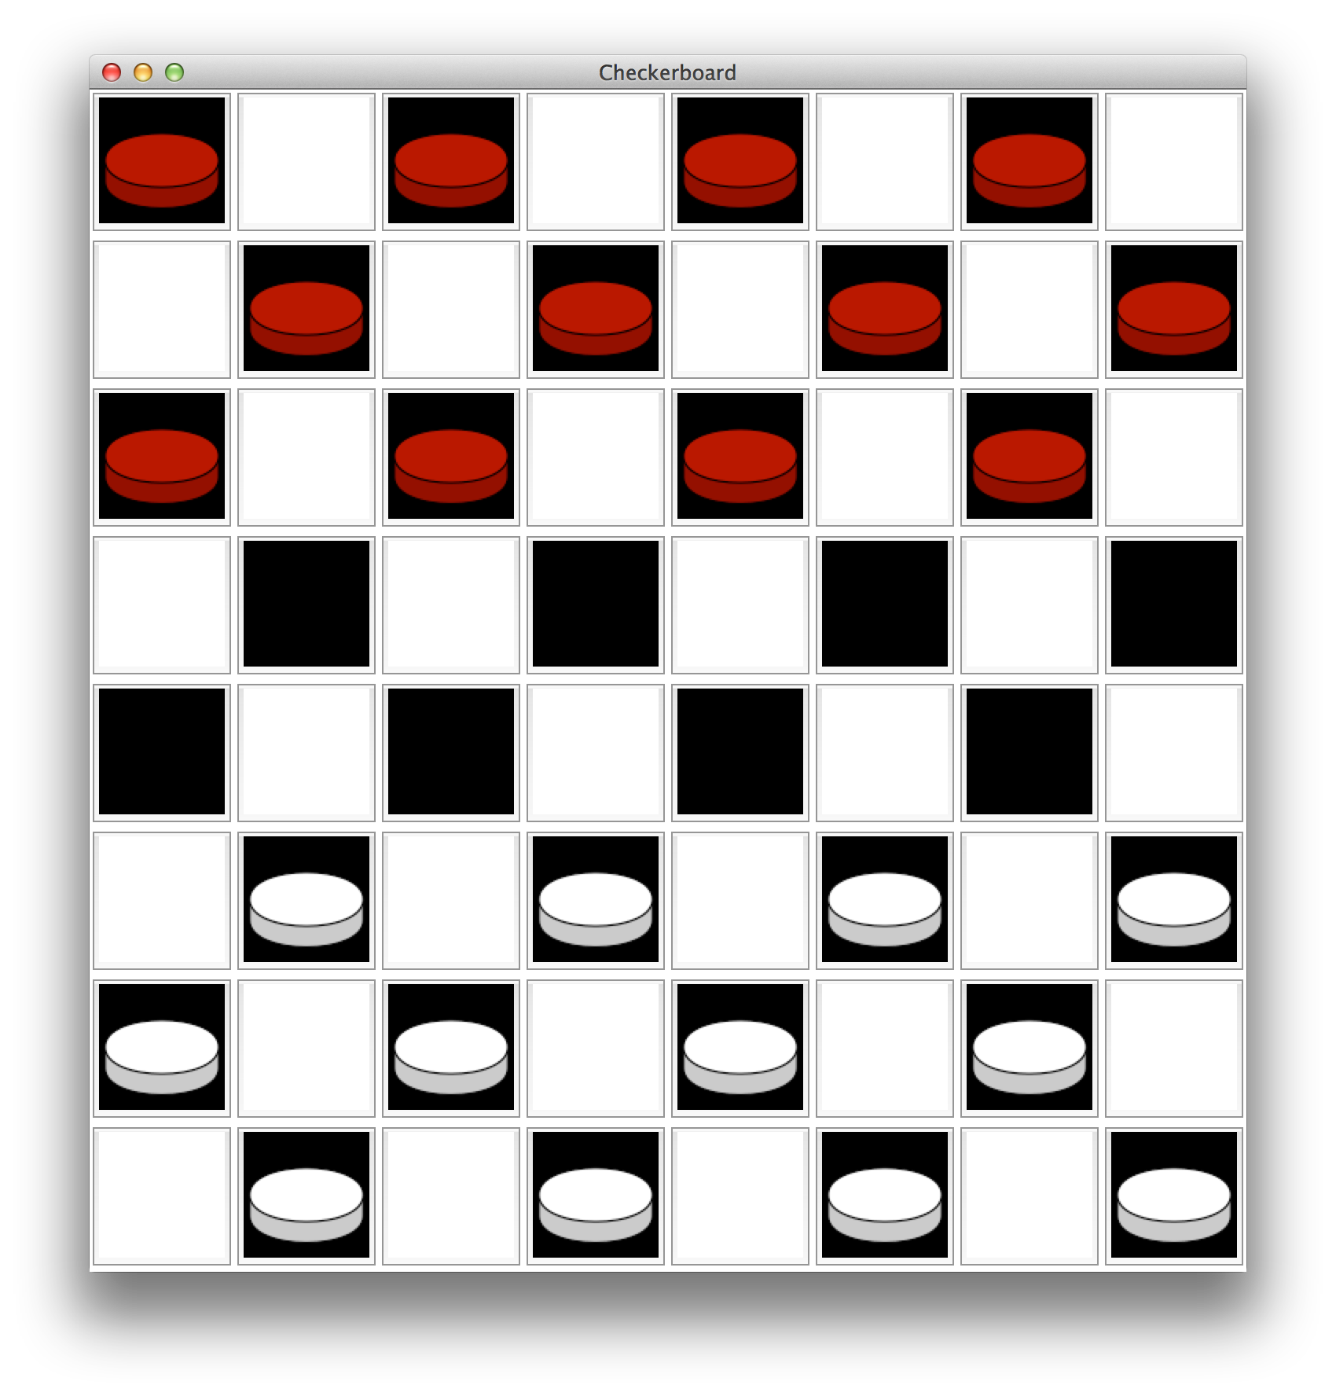

Mark Donohue, Mannan Kasliwal, Marc Suesser, and Zachary Ziccardi

This program allows two users to play a simple game of checkers. The program follows most basic rules found in an ordinary game of checkers.

The basic rules of checkers are as follows:

* Regular checkers may only be moved one space diagonally in the forward direction.
* A checker may only move more than one space if it is jumping an opponent’s piece. (See the picture below.)
* A piece may only move backward if it is a king.
* To become a king, a piece must reach the last row on the other side of the board.
* To win the game, a player must jump over all of the other player’s pieces.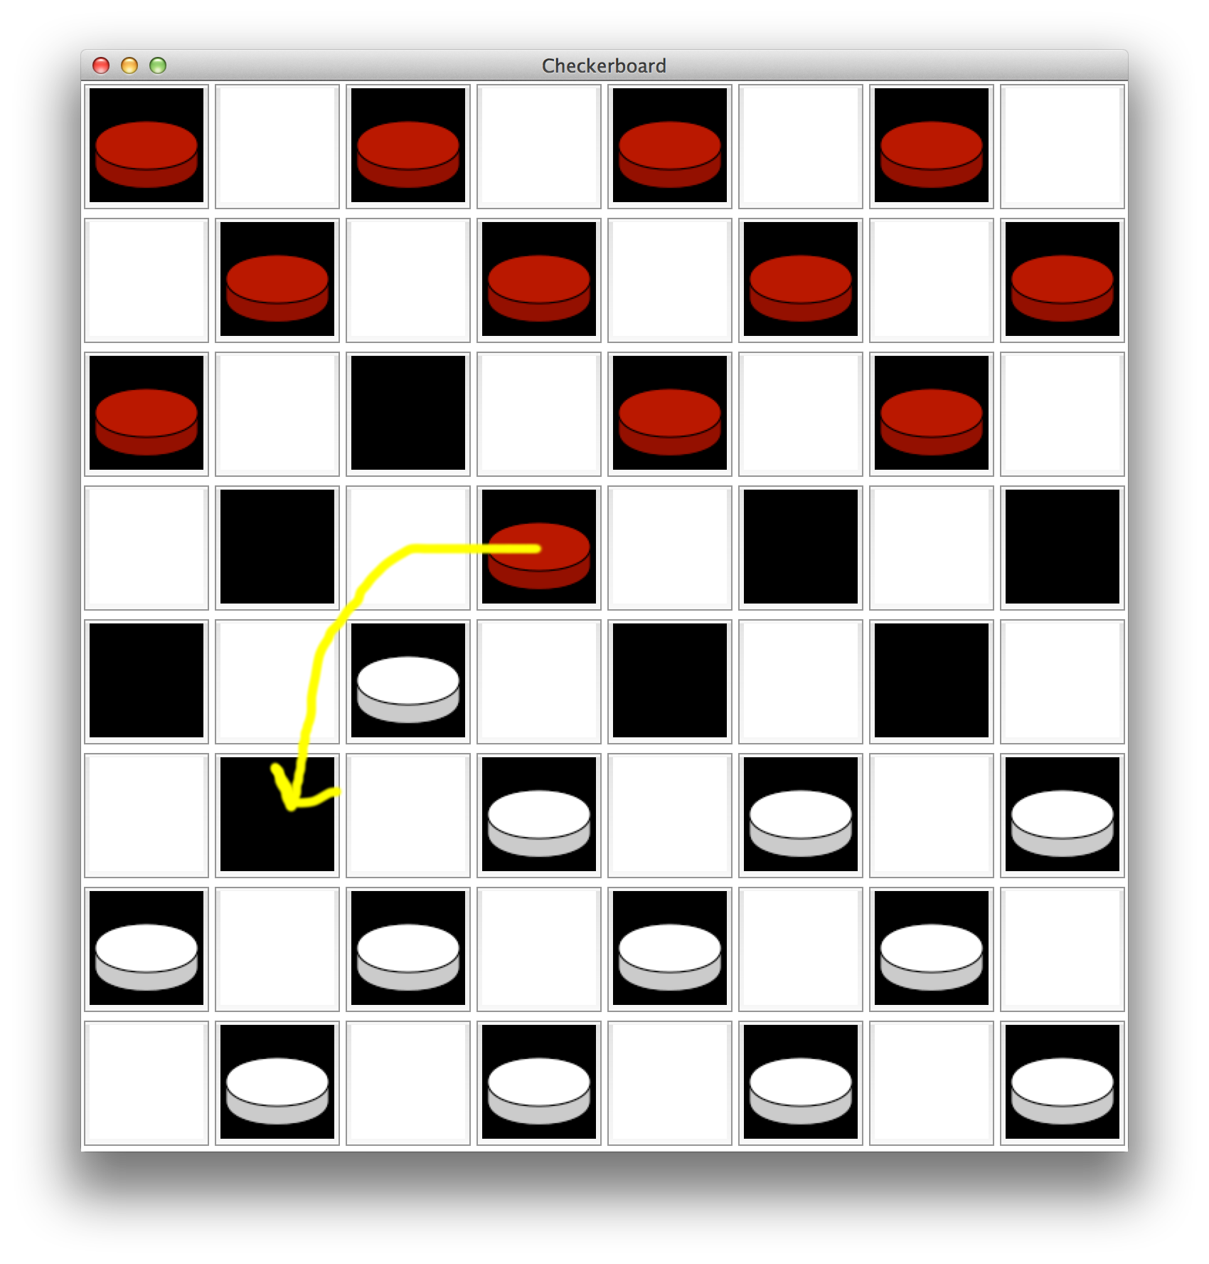

At the beginning of the game, a window pops up on the right side of the screen, allowing the players to enter their names. Once this is done, it will display who goes first.

INSERT PICTURE - of side menu

The player who controls the red team goes first. This player clicks on the checker they wish to move. Then, they click on the space they would like the checker to move to. If the space they select is a valid space, the checker will move to the new space, and it is now the opposite player’s turn. If the space they choose is invalid, the checker will not move and the player must choose a new, valid space.

A message is displayed to alert the player that they tried to make an incorrect move.

INSERT PICTURE - of message displayed (which is in the side menu…hopefully)

If the player has already selected a checker piece and would like to change his or her mind, they can click that piece again to deselect it, then click whichever other piece they wish to move.

The game ends when one player has jumped all opposing pieces. A message will be displayed to notify the winner.

INSERT PICTURE – of ‘winner’ message (in side menu, hopfully)